Inch by Inch
Grade Level: 1

Mathematics Domain and Cluster:

Domain: Measurement and Data
Cluster: Measure lengths indirectly and by iterating length units

Common Core standard(s) being assessed (if the task is intended to assess only one part of the standard, underline that part of the standard):

1.MD.2: Express the length of an object as a whole number of length units, by laying multiple copies of a shorter object (the length unit) end to end; understand that the length measurement of an object is the number of same-size length units that span it with no gaps or overlaps. Limit to contexts where the object being measured is spanned by a whole number of length units with no gaps or overlaps.

Student Materials:

- Student Assessment Task Sheet
- Pencil
- Set of “inchworms” (non-standard measuring units), one set per student

Teacher Materials:

- “Inch by Inch”, written by Leo Lionni

Directions (for teacher to administer assessment task):

- Read “Inch by Inch” by Leo Lionni.
- Ask: What was the inchworm doing? Why was he/she doing it? Why do we really measure things?
- Say the prompt.
- Pass out a student assessment sheet and set of inchworms to each student.
- Review the directions for completing the task. Clarify where they should start and end their measurements for each of the characters. Repeat these directions as necessary.
- Circulate to observe students as they perform their measurements to collect additional assessment evidence.

Prompt:

Do we know how long the robin’s tail, the flamingo’s neck, the heron’s leg, and the hummingbird is? Let’s find out!

Correct or Model Answer:

- Robin’s tail: 2
- Flamingo’s neck: 4
- Heron’s legs: 3
- Hummingbird: 3 (from head to tail)

Example of a short constructed response:
I started by putting an inchworm at the end of the hummingbird’s tail. The edge of the inchworm was touching the edge of the tail. I lined up more inchworms until I reached the top of the hummingbird’s head. I lined them up end-to-end and did not overlap the inchworms. Then I counted them to see how many inchworms there were from one end of the hummingbird to the other.

Scoring Guide/Rubric (a score should be awarded for each criterion below)
Criteria (CCSS code) | 0 points | 1 Point | 2 Point
1.MD.2: Express the length of an object as a whole number of length units | Student requires assistance to use non-standard units to measure the length of ribbon | Student is able to use non-standard units to measure the length of the ribbon with some inaccuracies | Student is able to use a variety of non-standard units to accurately measure the length of the ribbon
1.MD.2: Understand that the length measurement of an object is the number of same-size length units that span it with no gaps or overlaps | Student needs assistance or prompting in describing how to use non-standard units to measure an object. The concept of placing units end-to-end is not evident. | Student is able to describe how non-standard units are used to measure an object, but understanding that the units must be placed end-to-end or without gaps or overlaps is not evident | Student is able to describe how non-standard units are placed end-to-end on an object in order to measure its length

Teacher’s Notes:
This task may also support the following language arts standards:
- 1.RL.1: Ask and answer questions about key details in a text.
- 1.RL.7: Use illustrations and details in a story to describe its characters, setting, or events.

Inch by Inch

Student Assessment Worksheet

Directions: Use your inchworm to measure the robin’s tail, the flamingo’s neck, the heron’s legs, and the hummingbird. Then tell us how you used your inchworm to do the measurements.

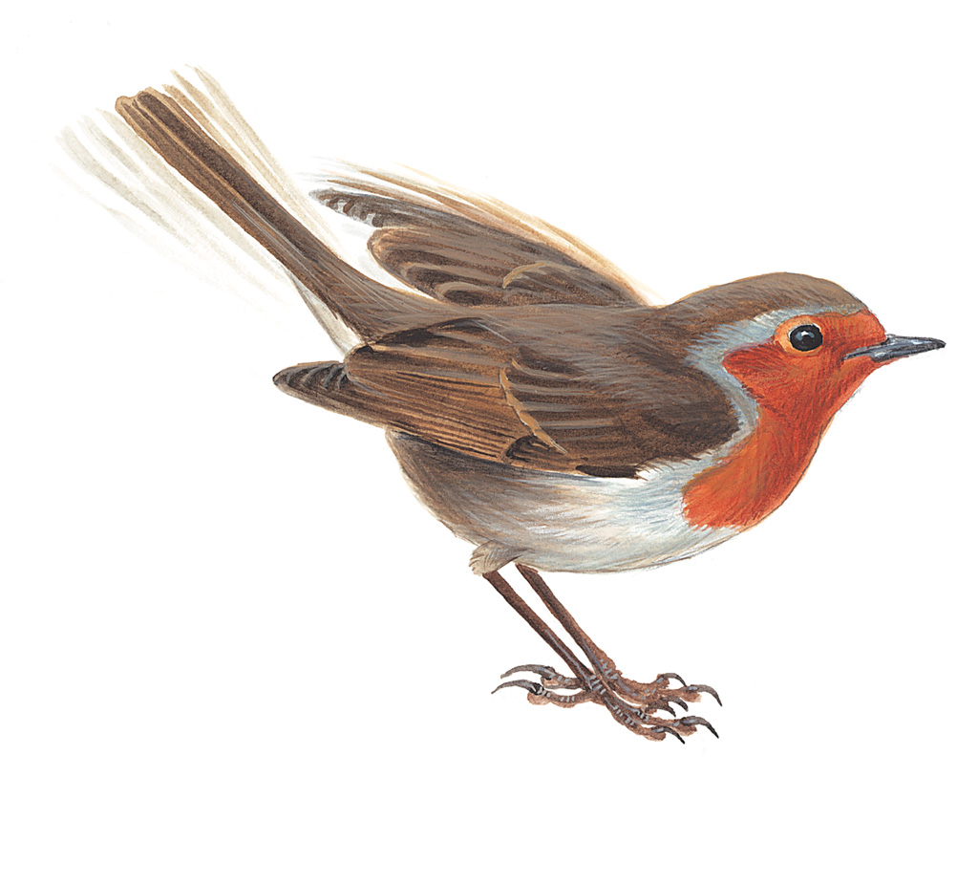
How many inchworms is the robin’s tail?
__________ inchworms

Inch by Inch

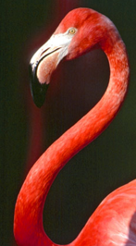 | 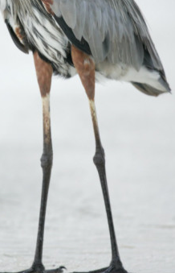
How long is the flamingo’s neck?  __________ inchworms | How long is the heron’s legs?  __________ inchworms

Inch by Inch

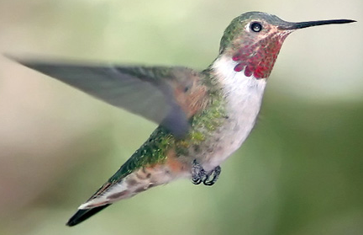
How many inchworms is the whole hummingbird?
__________ inchworms

Tell us how you used the inchworm to measure the hummingbird: _________________
________________________________________________________________________
________________________________________________________________________
________________________________________________________________________
________________________________________________________________________

Inch by Inch



